**PRESS KIT**

**Short Description**

Imagine yourselves enjoying a lovely evening of theater and a scrumptious three-course meal when suddenly someone among you commits a crime, possibly a MURDER!

​

The detectives walk in to find out who the suspect is but because you were all the witnesses, you have to help him solve the murder mystery.

Doesn't that sound like fun?

Oh... did we tell you? All the proceeds from this event will go to Women's Habitat and the Humber College Scholarship Fund.

Isn't it great to have fun for a good cause?

**Long Description**

**A Dinner to Die For** is a murder mystery dinner raising funds for Women's Habitat of Etobicoke, a community-based organization providing vital support to women and their dependents who are survivors of violence and poverty, as well as the Humber College Scholarship Fund.

The event is produced by a group of students in the Event Management post graduate certificate program at The Humber Institute of Technology and Advanced Learning. An anchor of this program is our Capstone event, where students are required to put our learning into action by creating, planning and executing a major off-campus fundraising event. Our event is on Friday, April 13, 2018 at Amsterdam Brewing Company in Toronto, ON.

From 7pm and 10pm guests will enjoy a three course dinner while witnessing a murder and attempting to solve the crime. The first guest who can correctly identify the murderer will be rewarded with a prize. Additionally, a silent auction, photo booth, dessert cart, and cash bar will be offered at the event for guests to experience.

**Charities**

Women's Habitat

Women's Habitat is a community-based feminist organization providing vital support to women and their dependents who are survivors of violence and poverty.  
They also offer services such as group and individual counselling sessions, support services, housing assistance, parenting support and systems to name a few.

Humber College

The Humber Scholarship Funds recognizes students who have not only excelled in their academics but also have shown par excellence in extracurricular activities, community involvement etc.

**Flyer**

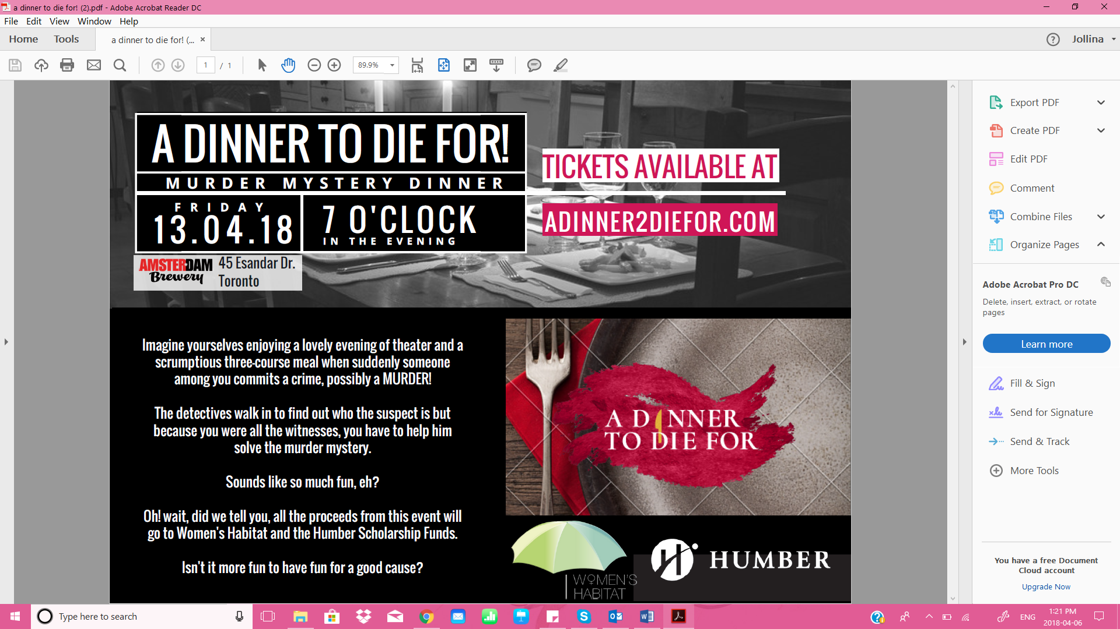

**Fact Sheet**

Fact Sheet

**A Dinner to Die For – Murder Mystery Dinner & Theatre**

*Humber Student Event Management Fundraising Event*

**Event Date & Time:**

Friday April 13, 2018

7pm - 10pm

**Event Location:**

Amsterdam Brewery

45 Esandar Drive,

Toronto, ON., M4G 4C5

(416) 504-1040

**Total Number of Guests:**

80

**Ticket Price:**

$55.00

**Supported Charities:**

Women’s Habitat

140 Islington Ave.

Etobicoke, ON, M8V 3B6

habitat@womens-habitat.ca

Humber Scholarship Fund

205 Humber College Blvd.

Etobicoke, ON, M9W 5L7

<https://business.humber.ca/programs/event-management.html>

**Event Website:**

www.adinner2diefor.com

**Event Contact:**

Nove Events

[noveevents2018@gmail.com](mailto:noveevents2018@gmail.com)

905 376 9305